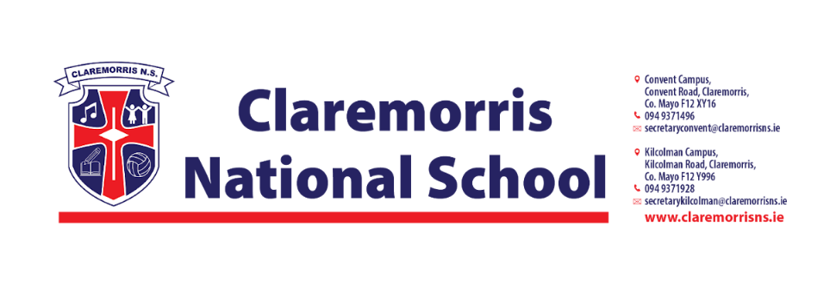
Senior Infants Stationery List
2025/2026

All school books, workbooks and copies will be funded by the Department of Education and bought by the school.

Children should bring the following items to school on 28th August:
1 x Plastic A4 Mesh Folder – homework folder (with zip)
1x Rubber/Eraser
2 x Pritt Stick 43g
2 x Black Whiteboard Markers
2 x Crayola Twistables (1 for school & 1 for home)
4 x 15A Blue Ormond Project Copy Book – Top blank, bottom wide ruled (40pages)

Please do not label these items.

Senior Infants do not need a pencil case in school.

In line with our Green Schools Policy, each child must have a reusable bottle and lunchbox. Tinfoil is not permitted for wrapping lunches.

