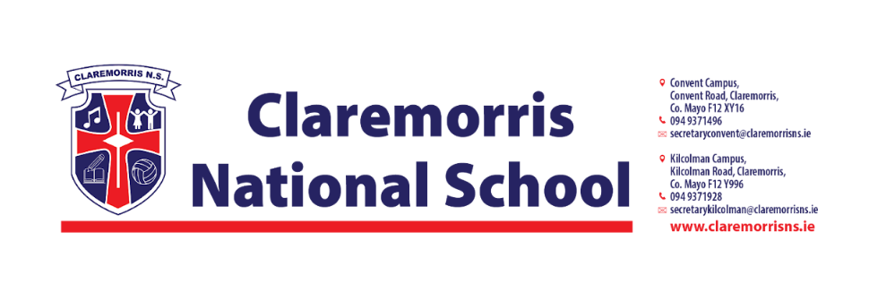
4th Class Stationery List
2025/2026
All school books and workbooks will be funded by the Department of Education and bought by the school.
Children should bring the following items to school on 28th August:
1 x A4 Polly Pocket Display Book (60 Pages)
1 x A3 Plastic zipped Mesh Wallet (must be A3 in size)
2 x A4 Plastic zipped Mesh Wallet (must be A4 in size)
3 x HB Pencils
3 x Red Pen (Bic)
3 x Blue Pen (Bic) (Individual pens only please)
1 x Small Scissors
1 x Pencil Sharpener
1 x Eraser
1 x 30cm Ruler
2 x Pritt Stick
1 x Small Sellotape

4mm Knitting needles and large ball of wool (Pick any colour)
1 pack of Colouring Pencils/Twistables
1 pack of 4 Whiteboard Markers
1 x Calculator
2 x 88 page Sums Copy
2 x 88 page Writing Copies
3 x A4 Manuscript Copies with Durable Plastic Cover (Not Hardbacks)
1 x Earphones/Headphones (Keep from 3rd Class)

In line with our Green Schools Policy, each child must have a reusable bottle and
lunchbox. Tinfoil is not permitted for wrapping lunches.

