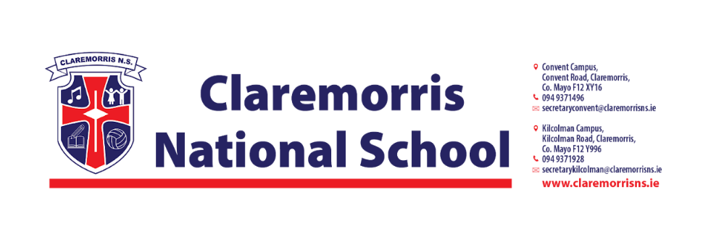
Junior Infants Stationery List
2025/2026

All school books and workbooks will be funded by the Department of Education & Youth and bought by the school.

Children should bring the following items to school on 28th August 2025:
1 x Plastic A4 Mesh Folder – homework folder (with zip)
2 x Pritt Stick 43g
2 x Crayola Twistables (1 for school and 1 for home)
1 x Ormond Junior Sum Copy (32 pages)
2 x Ormond Practice Book Blank (32 pages)
2 x Black Whiteboard markers

Junior Infants do not need a pencil case in school.

In line with our Green Schools Policy, each child must have a reusable bottle and lunchbox.
Tinfoil is not permitted for wrapping lunches.

